

# **Project report**

**Instagram User Analysis**

**INTRODUCTION**

User analysis is a crucial process for tracking how users engage and interact with digital products such as software or mobile applications. Instagram is a highly popular social media platform that requires constant user analysis to derive business insights for marketing, product, and development teams. This report aims to provide detailed insights into the questions asked by the management team for Instagram's user analysis.

**The analysis of the project was carried out on the following points give bellow:**

**A: Marketing**

* **Rewarding Most Loyal Users:**

The marketing team wants to find the People who have been using the platform for the longest time.So our Task is to Find the 5 oldest users of the Instagram from the database provided.

To carryout this task we used the following query command:

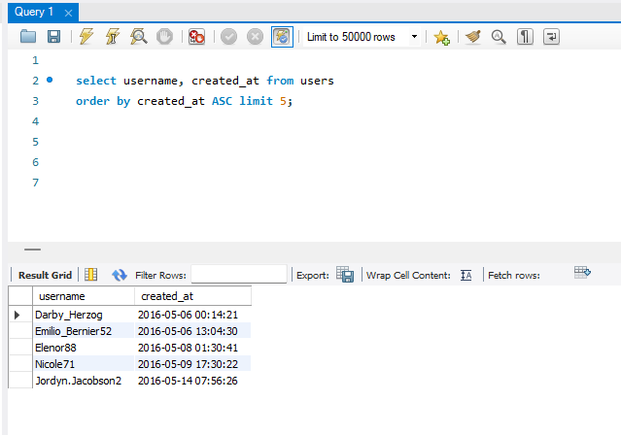

**output /result**

* **Reminding Inactive Users to Start Posting:**

The marketing team wants to remind inactive users to start posting by sending them promotional emails. Our task was to find the users who have never posted a single photo on Instagram.

To carryout our task I have used the following query command:

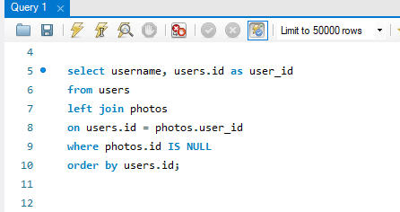

**output/result**

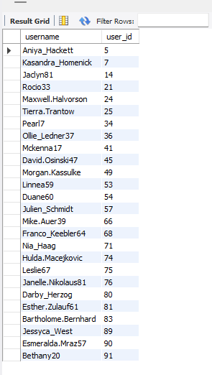

So, from the above out put it can be concluded that there as 26 users out of the 100 users who have never posted a single photo on Instagram.

* **Declaring Contest Winner:**

The team started a contest, and the user who gets the most likes on a single photo will win the contest. Now they wish to declare the winner. Our task was to identify the winner of the contest and provide their details to the team.

To carry out our task I have used the following query command:

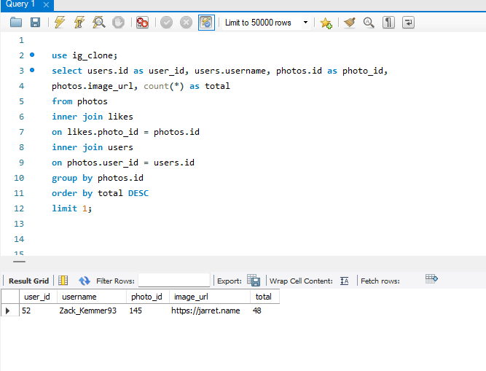

So, from the above output it is conclude that the user named Zack_Kemmer93 with user_id 52 is the winner of the contest cause his photo with photo_id 145 has the highest number of likes which is 48.

* **Hashtag Researching:**

A partner brand wants to know which hashtags to use in their posts to reach the most people on the platform. Our task was to identify and suggest the top five most commonly used hashtags on the platform.

To carry out our task I have used the following query command:

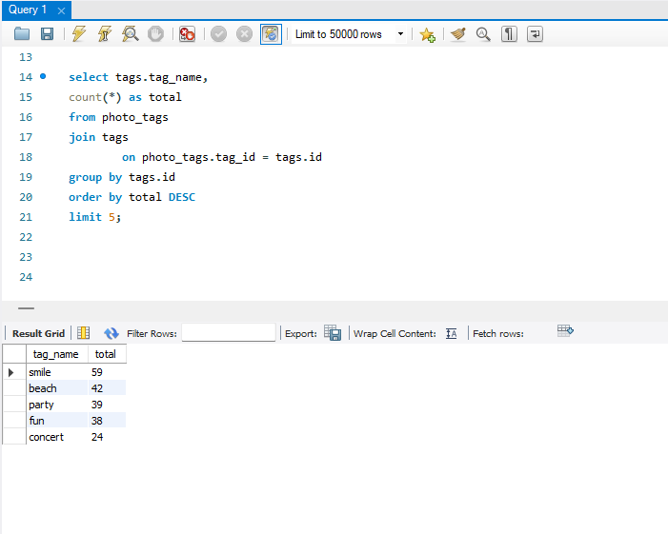

**output /result**

* **Launch AD Campaign:**

The team wants to know which day would be the best day to launch ADs. Our task was to identify the day of the week when most users register on Instagram to provide insights on when to schedule an ad campaign.

To carry out our task I have used the following query command:

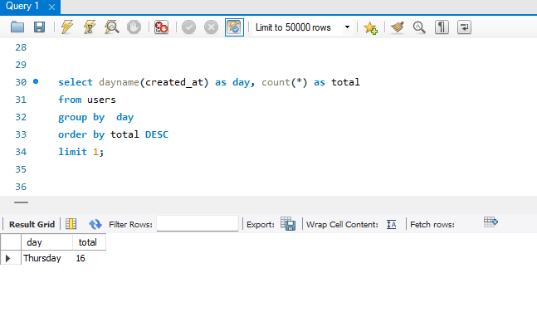

**output /result**

**B: Investor Metrics**

Assessment Our investors want to assess Instagram's performance based on user engagement and the presence of bots and fake accounts.

We have provided insights into two key metrics:

**User Engagement:** To determine the level of user engagement on Instagram, we analyzed the frequency of user posts

To carry out this task I have used the following commands

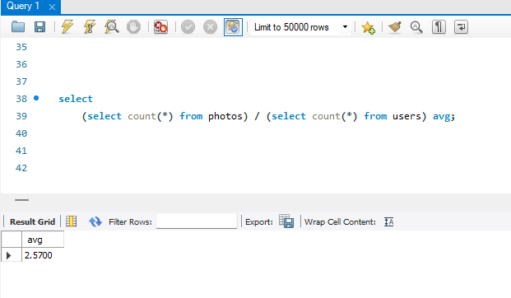

**output /result**

**Bots & Fake Accounts:**

`The investors want to know if the platform is crowded with fake and dummy accounts.  
our Task is to Provide data on users (bots) who have liked every single photo on the site (since any normal user would not be able to do this).

To carry out this task I have used the following commands:

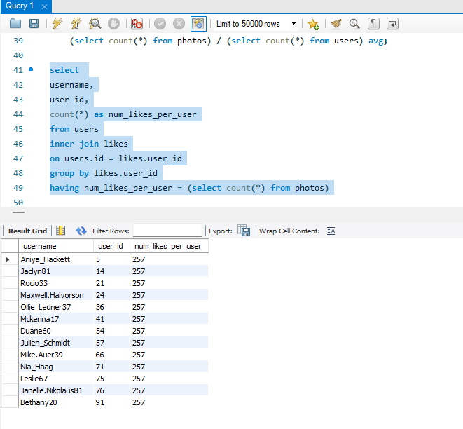

**output /result**